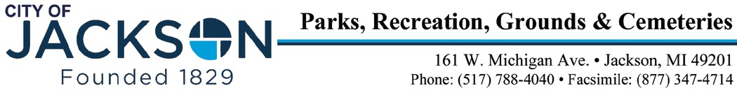

Jackson Public Art Commission Ex-Officio Members
Grant Bauman (City Representative) Jonathan Greene (Interim City Manager)
Jeremy Frew (Ella Sharp Museum)
Kaiti McDonough (City Representative)
Janet Meyer-Jackman (City Representative)

AGENDA

City of Jackson Public Arts Commission
Meeting of Tuesday, November 14, 2023 at 5:30 pm
10th Floor City Hall

I. Call to order

A. Attendance

B. Approval of the Minutes:

C. Announcements from Members and City Staff:

D. Approval of the Agenda

E. Treasurer Report:

II. Comments from the Public in Attendance (3 minutes) III. New Business
- Review project from Mary Tallman for Woodland Cemetery

IV. Other Business
- Future Agenda Items
B. Next Meeting: Tuesday, January 16, 2024

