Third Party User Instructions

Creating a Third Party Administrator

The Third Party needs to log into the admin console and accept the invitation

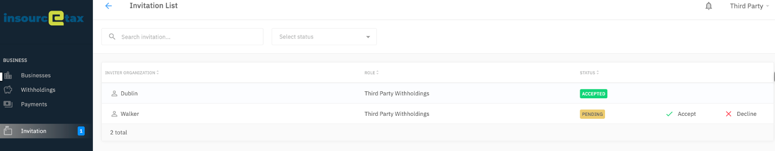

As the third party accepts invitations, they will appear in the city list. The active city will be highlighted with a green check mark

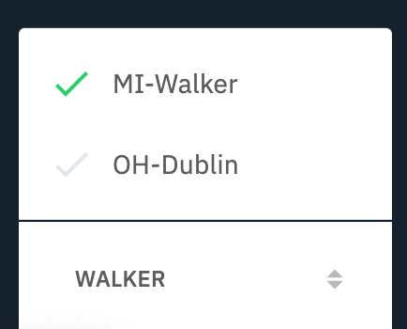

Adding a Business
While the Third Party is logged into the admin console, click on the Businesses link from the side menu. Download the CSV template.

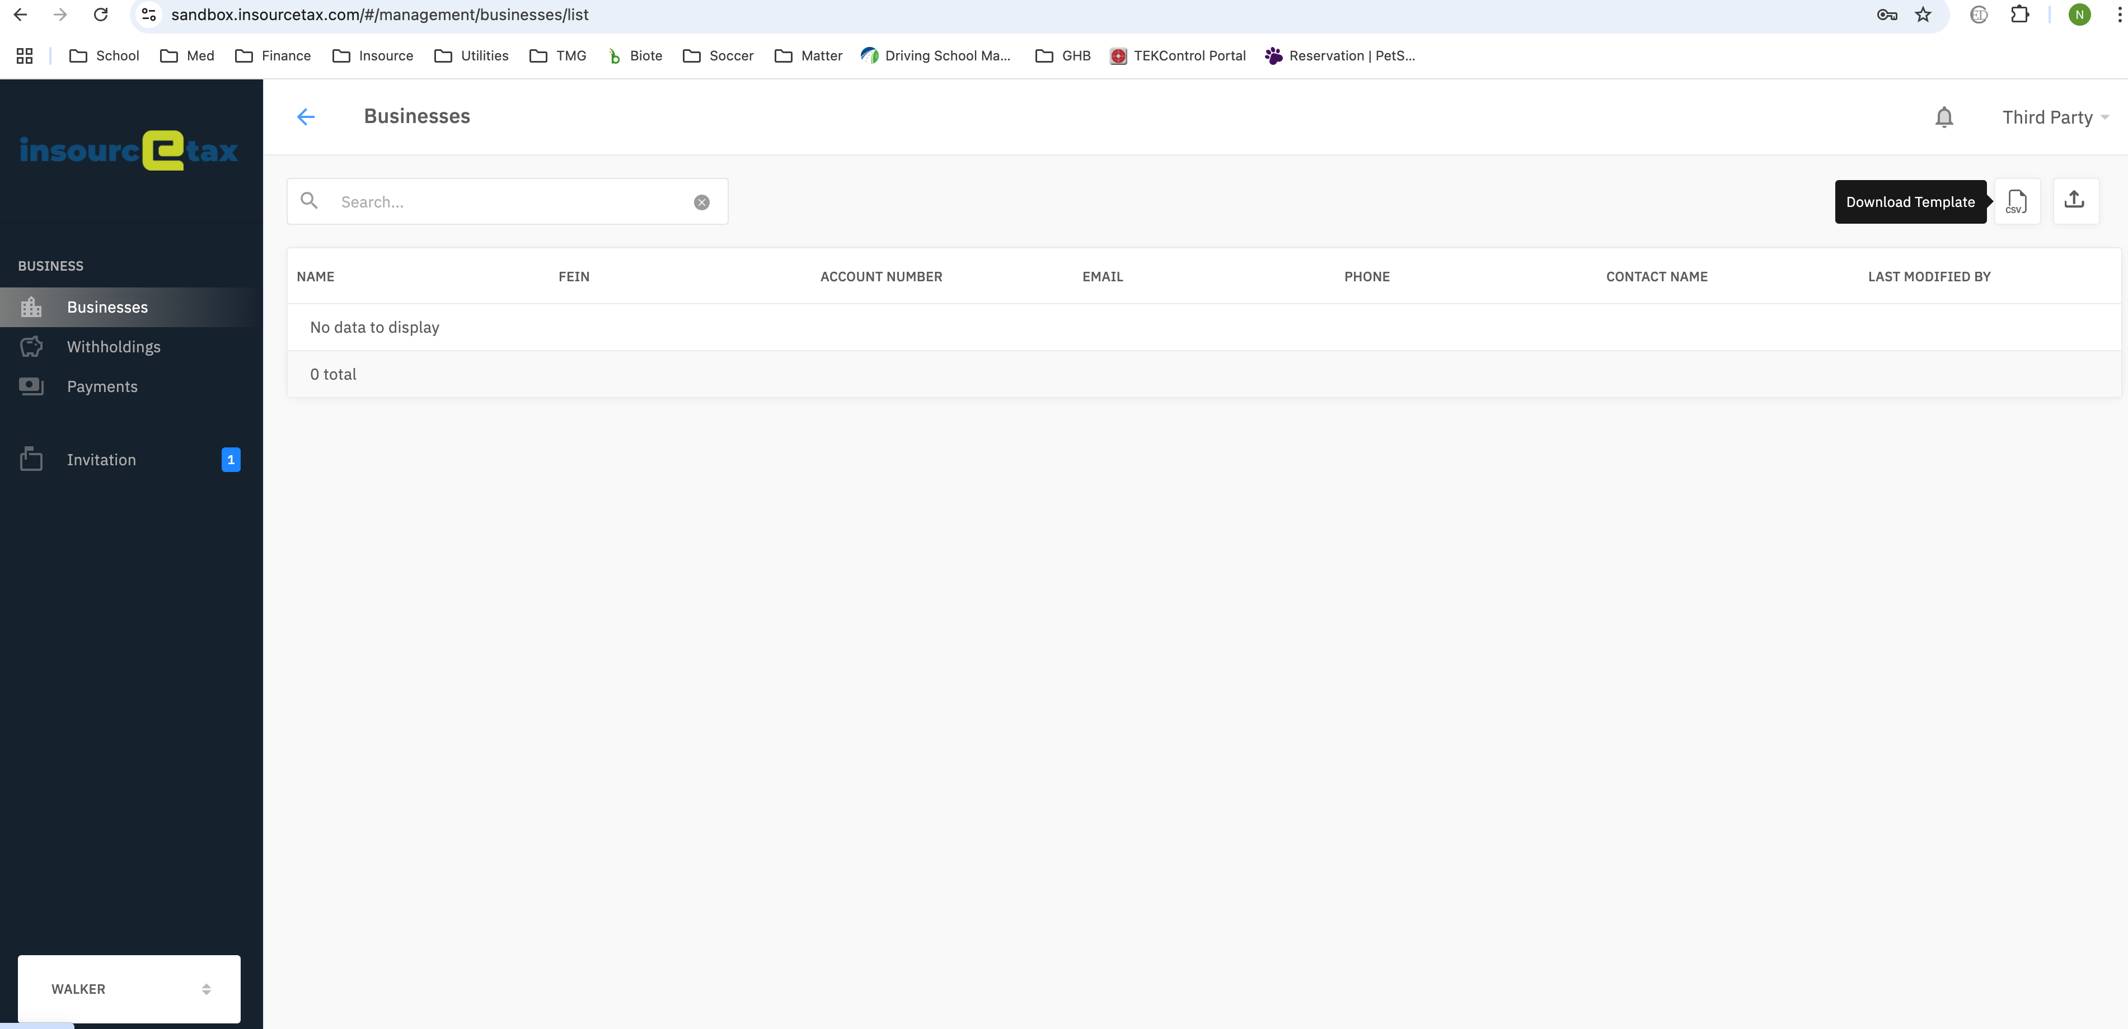

Add the FEIN and Account number for each business into the file.

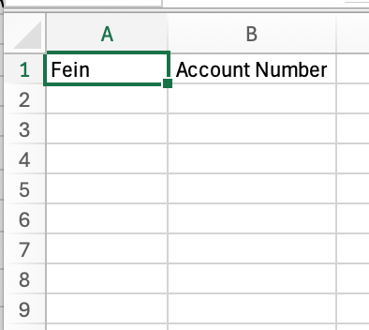

Click the upload button and a window will open. Select the file and click the Upload button.

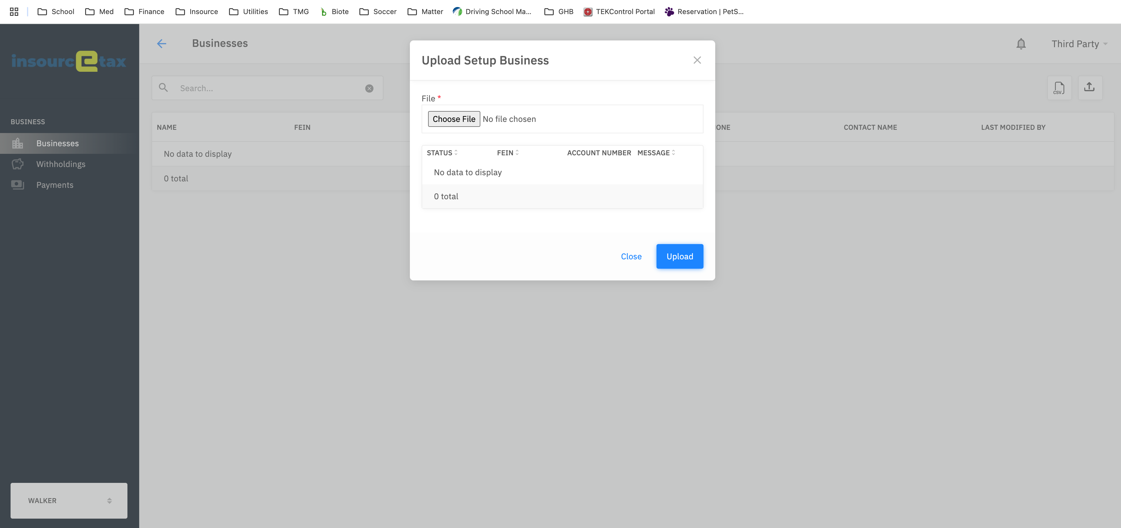

A status message will appear for each business in the uploaded file.

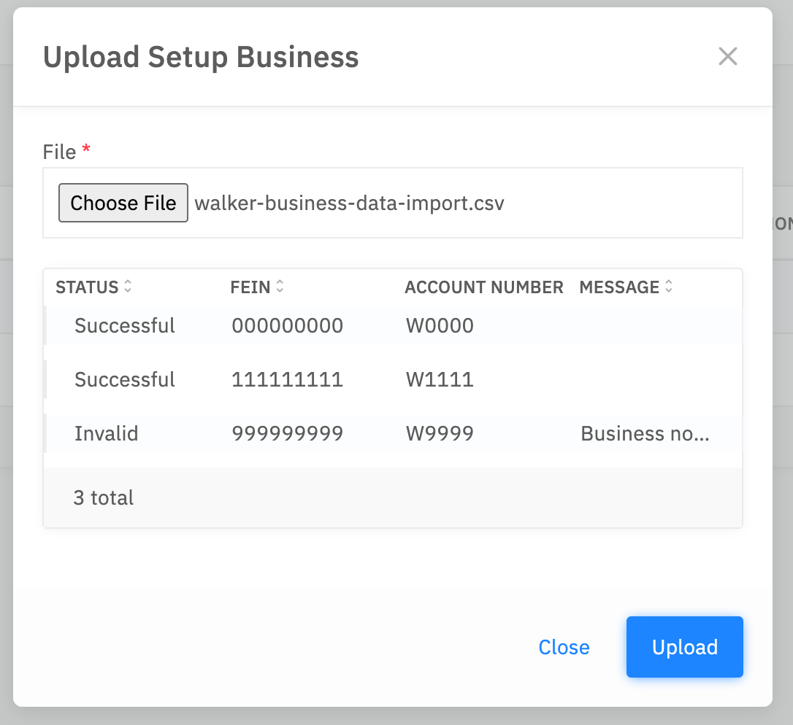

Each successful record will appear in the list of businesses.

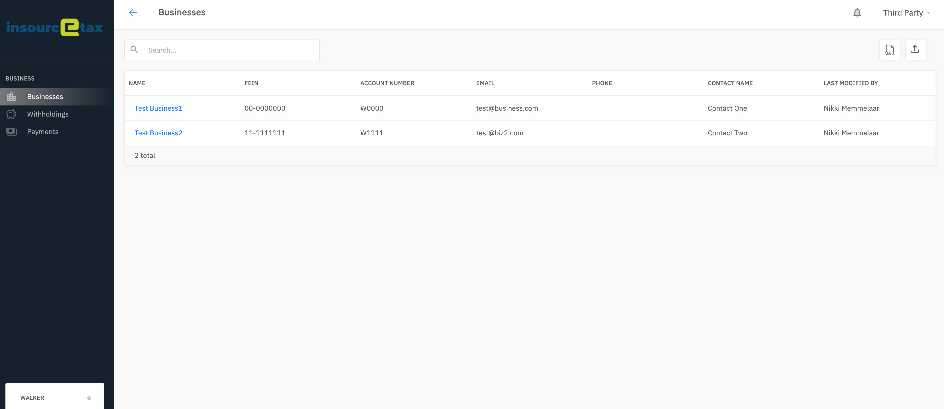

Withholdings

Withholdings – Create – Single Entry

To manually add a single withholding record, click on the Withholdings link in the side menu. And click on the Create button.

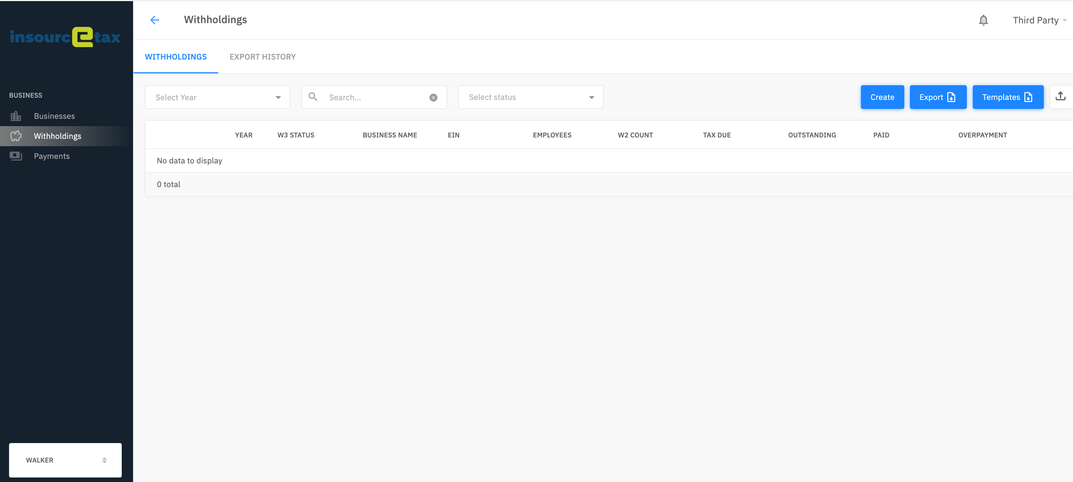

In the window that opens, select a tax year and business.

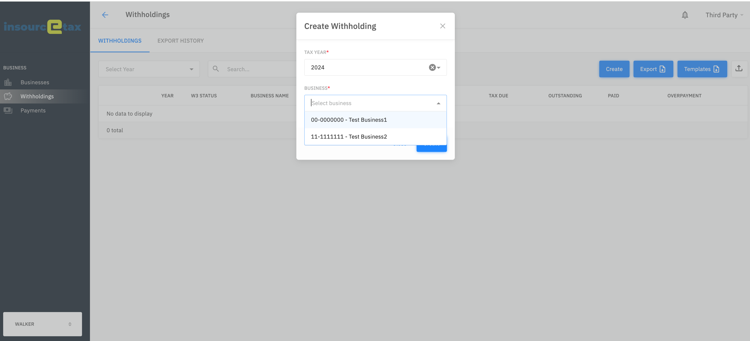

Once the WH has been created, click on the three dots and select Add Withholding Detail.

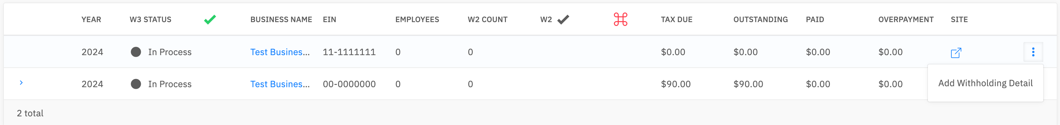

To be able to enter payment information, the business must have a default payment set up. Payment information can be entered in the Create Withholding Detail screen.

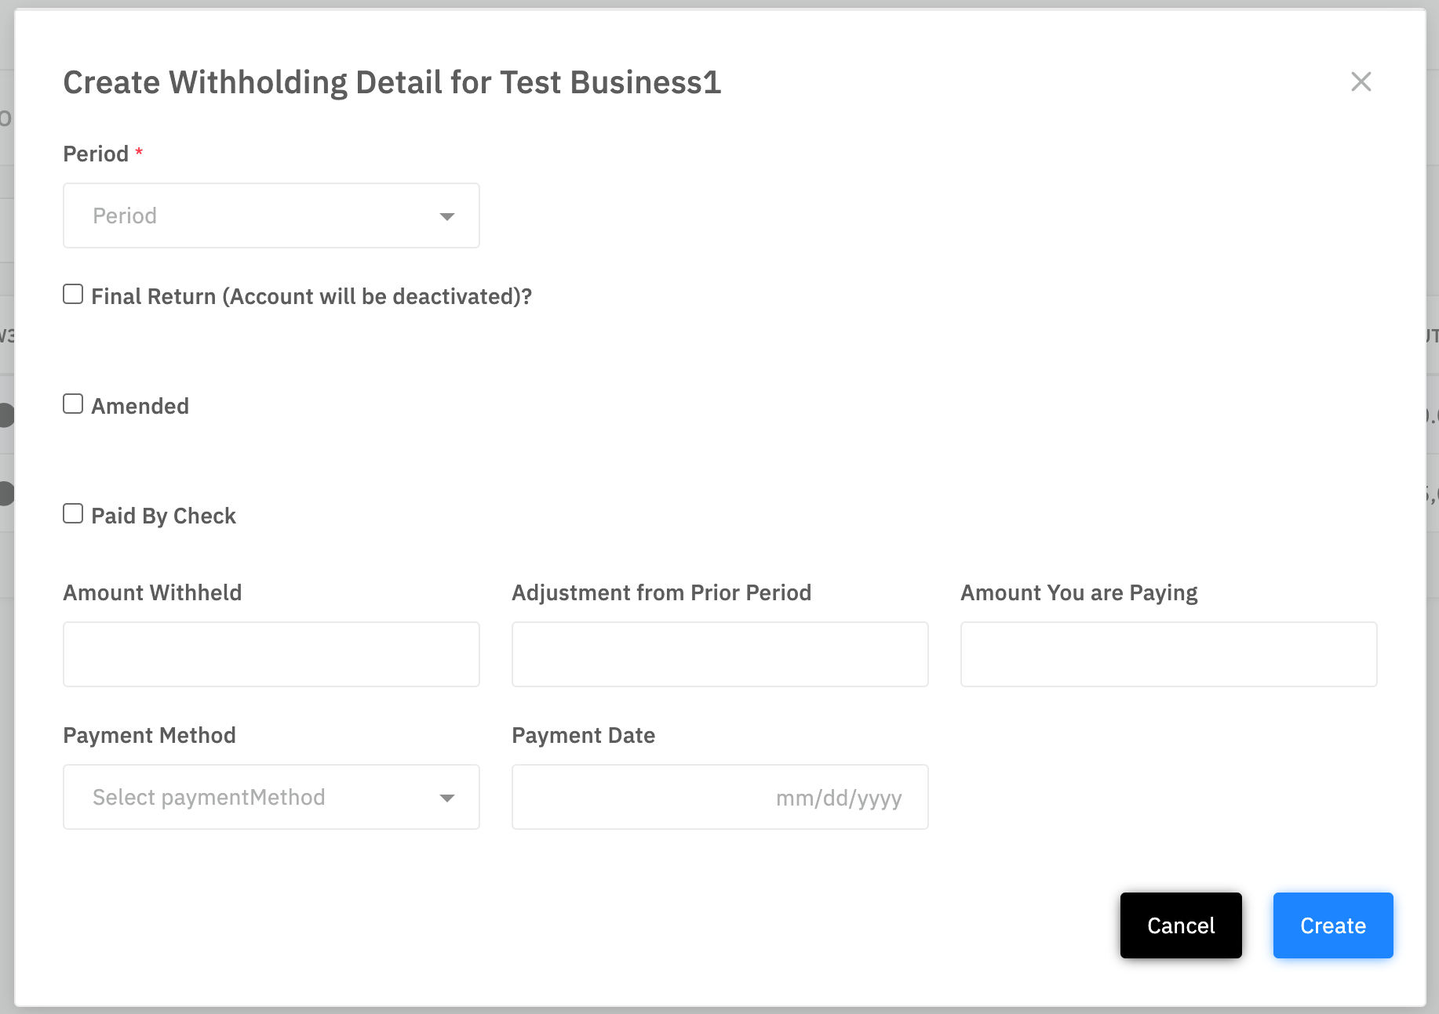

If the business does not have a default payment account set up, the Create Withholding Detail screen displays without the payment information fields.

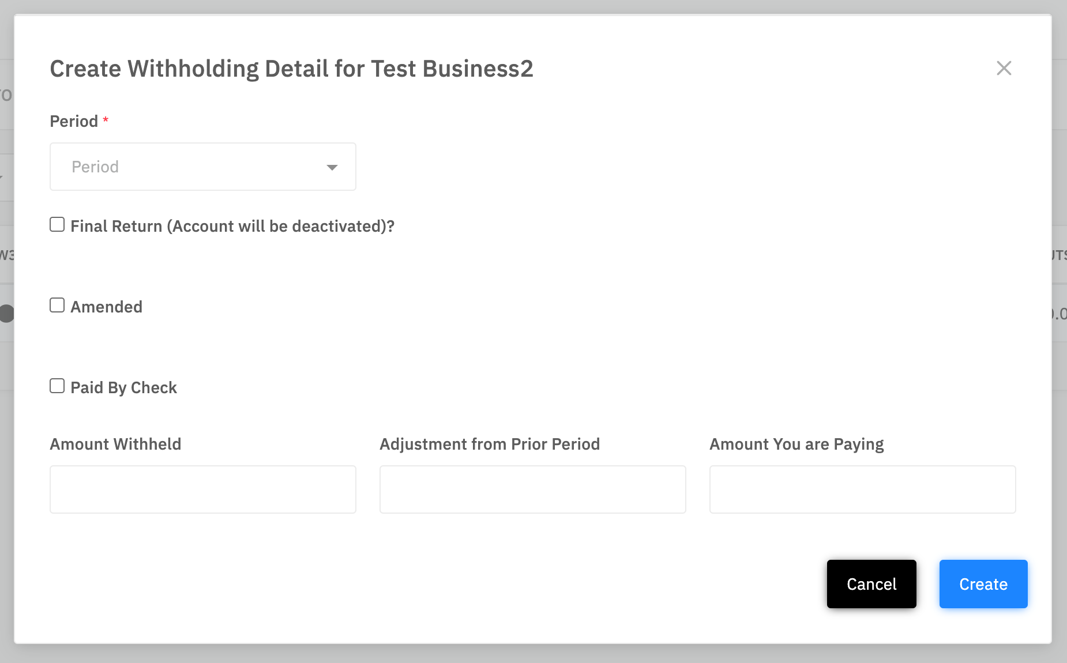

Enter in the information and click the Create button.

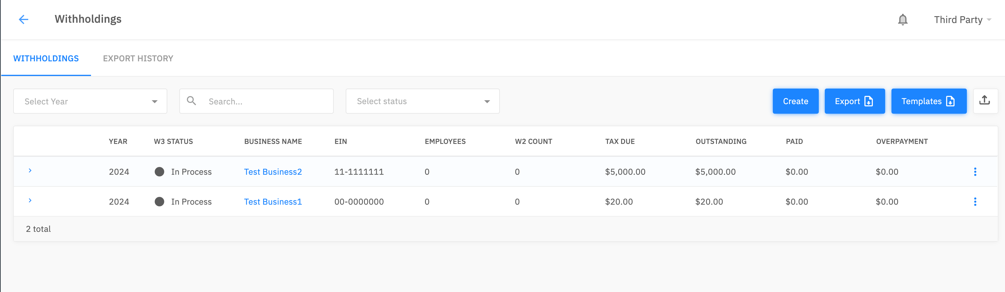

Expand the record to see the detailed information.

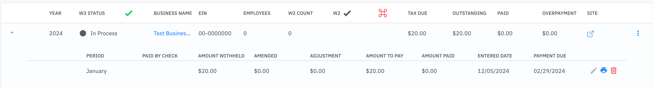

- To make updates to any of the information, click the pencil next to the record that you wish to change

Withholdings – Create – Bulk Upload

Filings

While on the Withholdings screen, click on the Templates button and select the Filing template to download it.

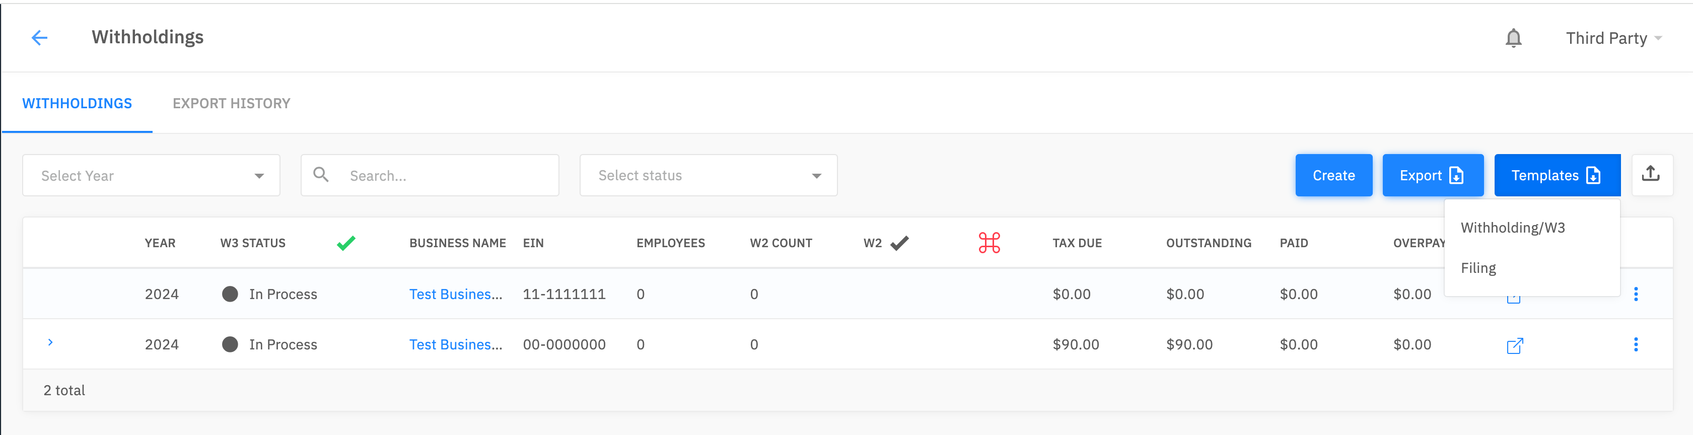

After you have filled in the template, save it to your computer and click the arrow button.



Choose a file and click the Upload button.

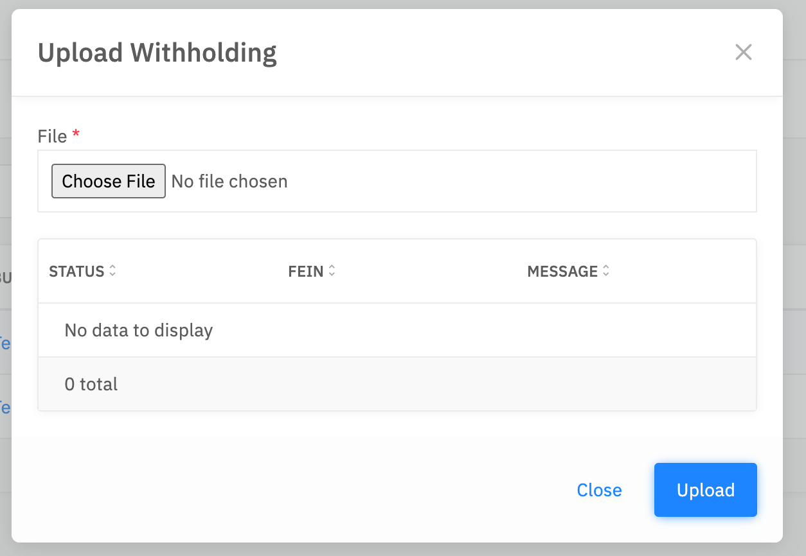

Once the file has been processed, the status of each record appears in the window.

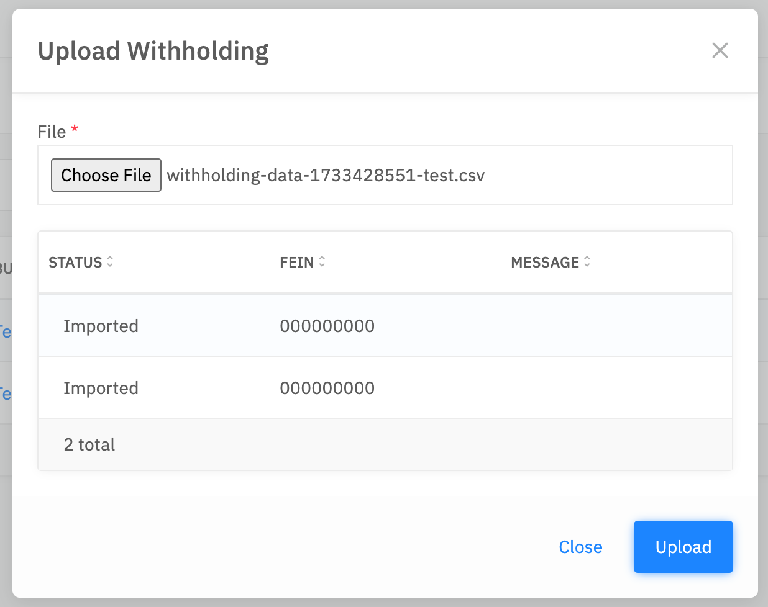

Expanding the detail section will display the withholding information that was uploaded.

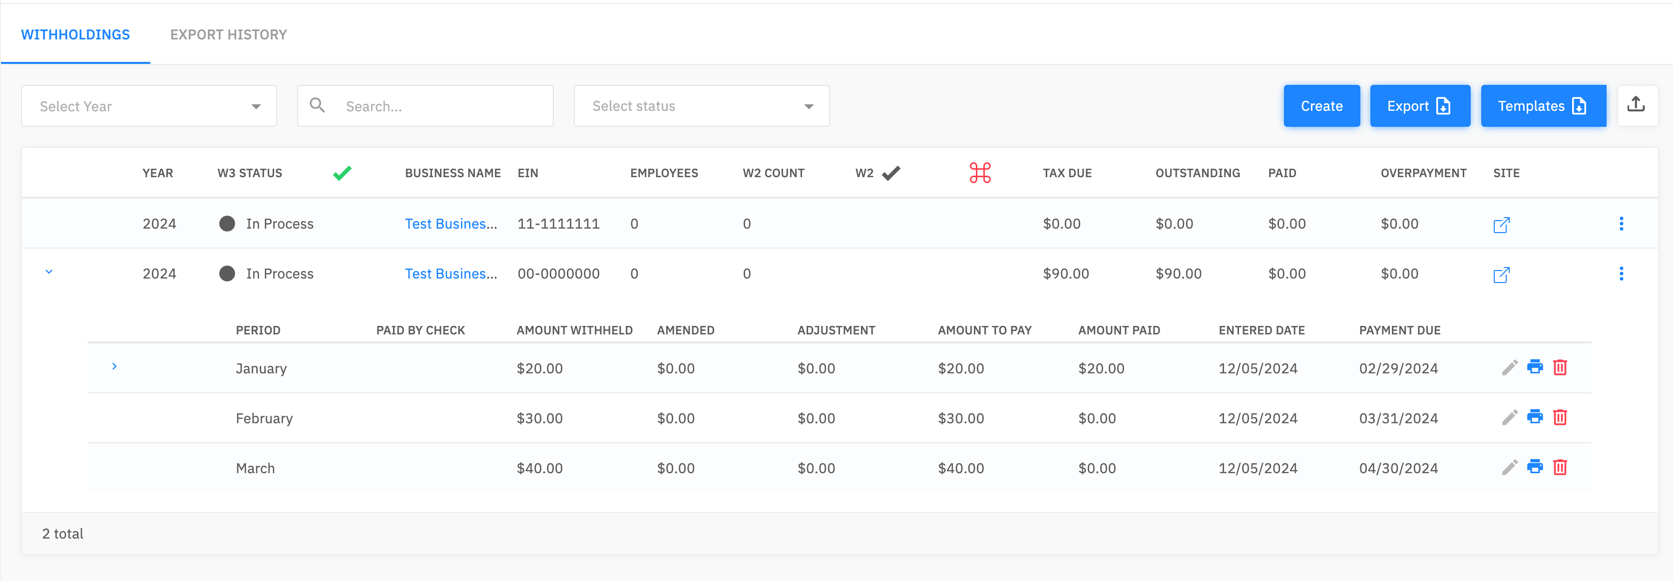

Filings file example
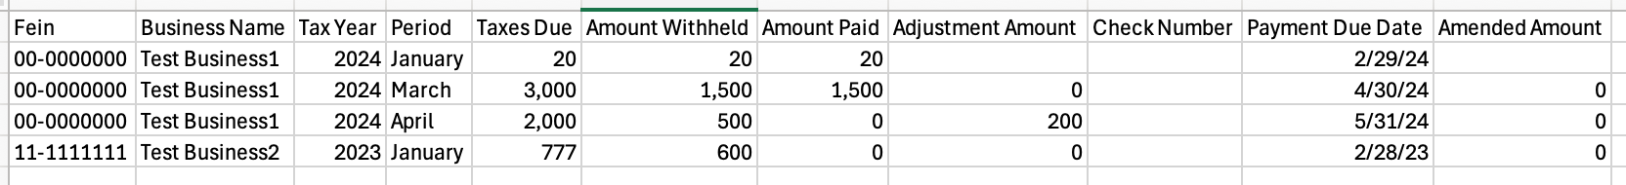
Whenever the Third Party makes an update in the admin console, the business will be able to go in and see the updates. For example, a Third Party performs the below actions:

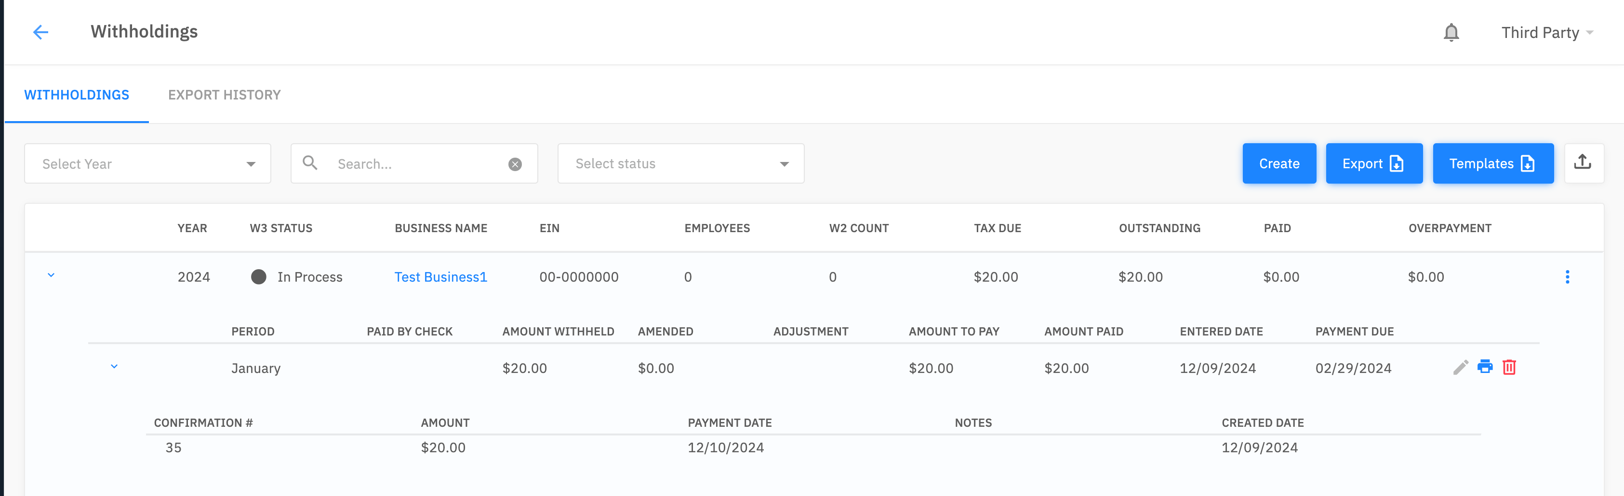

The business can log in and see this activity:

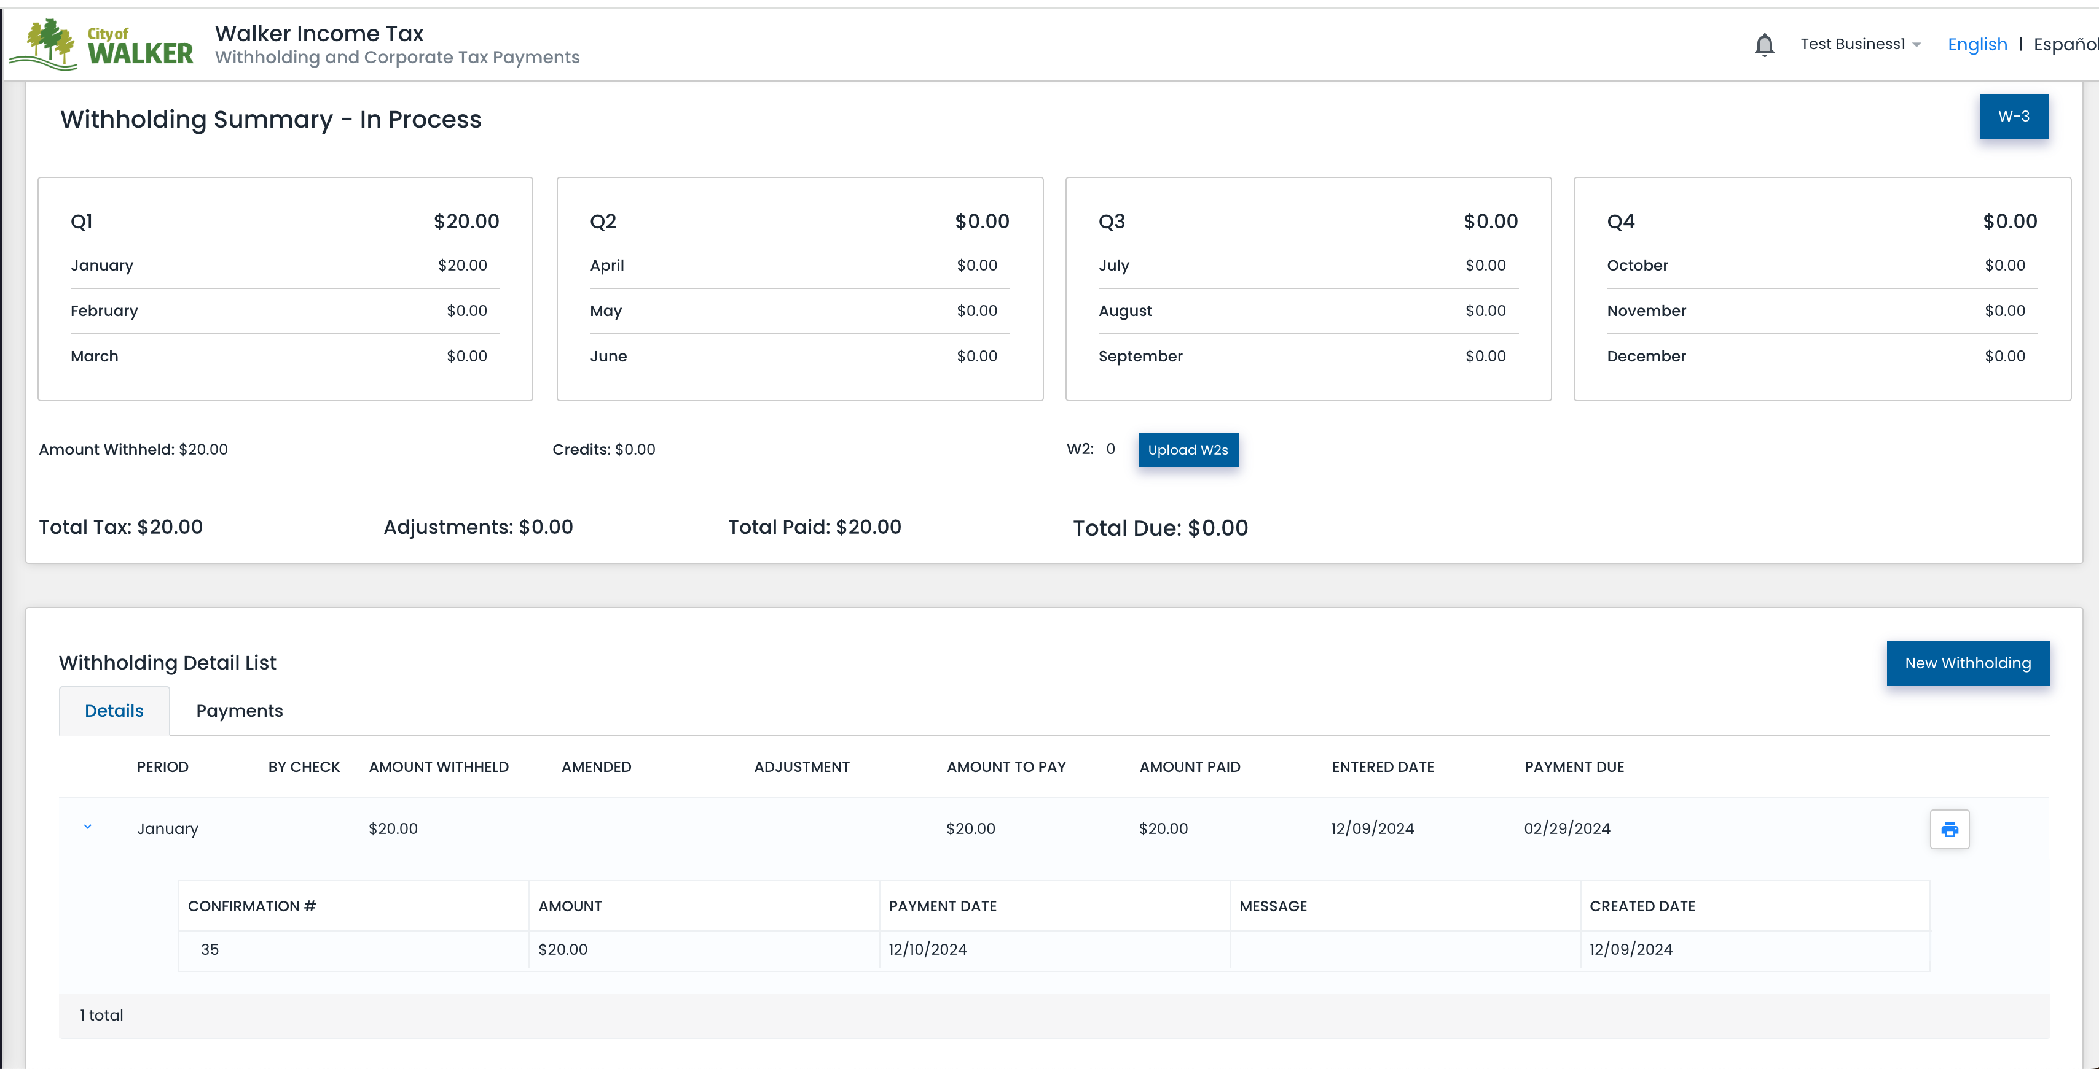

Withholdings – Create – Bulk W3 upload

W3
On the Withholdings screen, click Templates and download the template called W3.

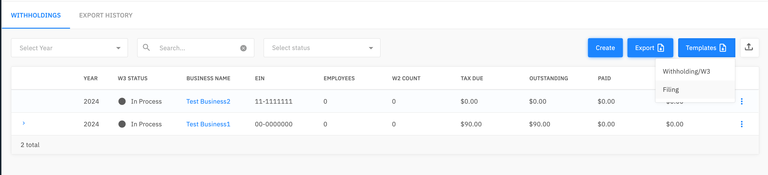

After you have filled in the template, save it to your computer and click the arrow button.

Choose a file and click the Upload button. Once the file has been processed, the status of each record appears in the window.

The status of the record changes to “Filed” once the W3 has been processed.

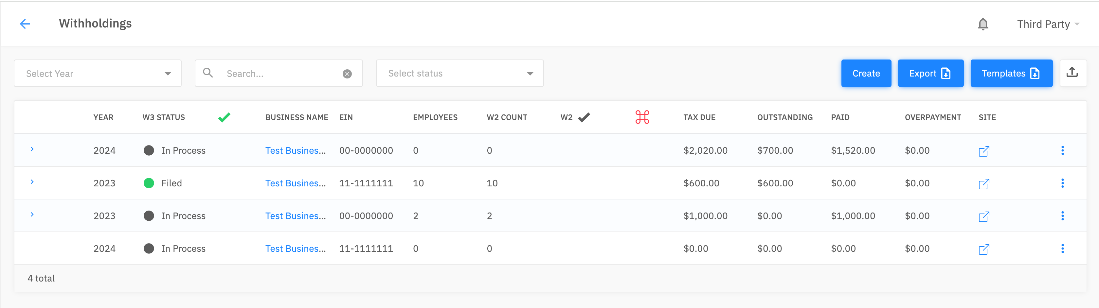

W3 file example

Payments

To view the payments, click on the Payments link on the side menu. This will display the payments that have been made for each business.

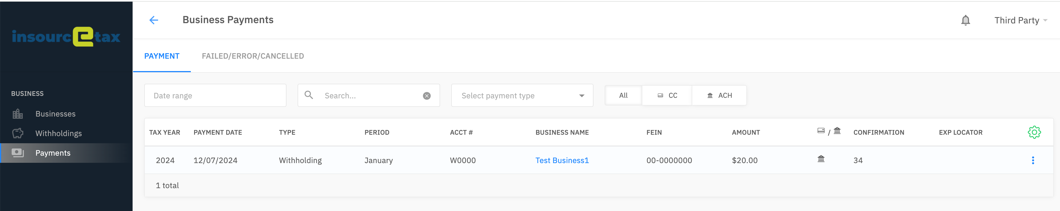
To delete a payment, click on the three dots and select Delete.

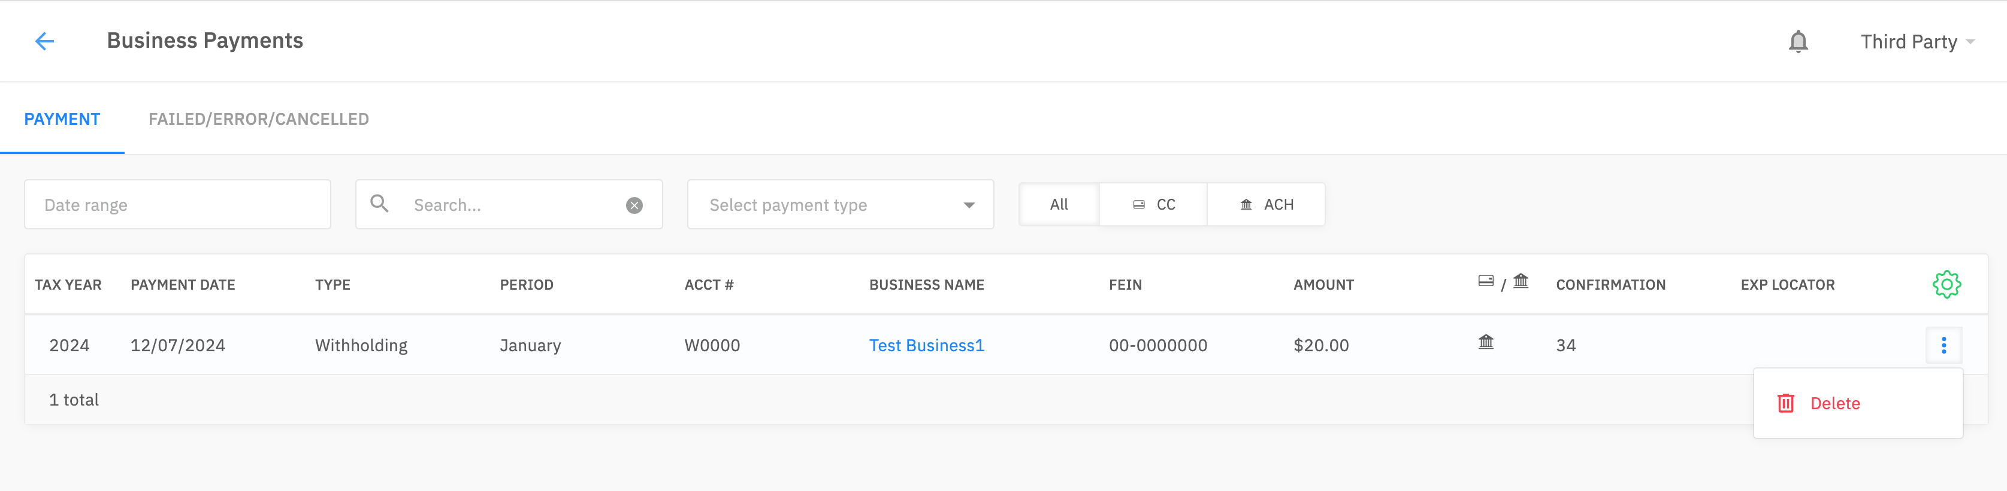

The information entered by the Third Party can be viewed and modified by the Business when they log into the system. If there are any payments that didn’t process, they will display on the Failed/Error/Canceled screen.

Templates

Withholding/W3
This template has the following fields:

FEIN | Required  May be entered with or without a dash
Tax Year | Required
Filed Flag | TRUE/FALSE  If this field is blank, it will create a new WH if one doesn’t already exist
Employees | Numeric
W2 Count | Numeric
W2 Amount Withheld | Numeric
Overpayment Type | Refund, Credit
Reconciliation Amount | Numeric
Amount To Pay | Numeric
Explanation | Alpha numeric
Generate Payment | TRUE/FALSE – If there is an underpayment and if a reconciliation needs to be created
Payment Date | Date format (MM/DD/YYYY)  If this field is left blank, the date will be calculated according to each City’s logic

Filing
This template has the following fields:

FEIN | Required  May be entered with or without a dash
Tax Year | Required
Period | Required  Values depend on how the business has been set up to file. See table below for acceptable values.
Taxes Due | Numeric
Amount Withheld | Numeric
Amount to Pay | Numeric
Check Number | If a check number is entered, the “amount to pay” field is what was paid
Generate Payment | TRUE/FALSE
Payment Date | Date format (MM/DD/YYYY)  If this field is left blank, the date will be calculated according to each City’s logic
Adjustment Amount | Numeric
Amended Amount | Numeric
Amended Comments | Alpha numeric
Final Return Flag | TRUE/FALSE
Final Return Comments | Alpha numeric

Acceptable values for the Period field:

January  February  March  April  May  June  July  August  September  October  November  December  First Quarter  Second Quarter  Third Quarter  Fourth Quarter  1st January  2nd January  1st February  2nd February | 1st March  2nd March  1st April  2nd April  1st May  2nd May  1st June  2nd June  1st July  2nd July  1st August  2nd August  1st September  2nd September  1st October  2nd October  1st November  2nd November  1st December  2nd December

